GIT CHALLENGE – 2
- Resolve Merge Conflicts
- merge conflict happens when Git cannot automatically combine changes from two branches because the same part of a file was modified differently in each branch.

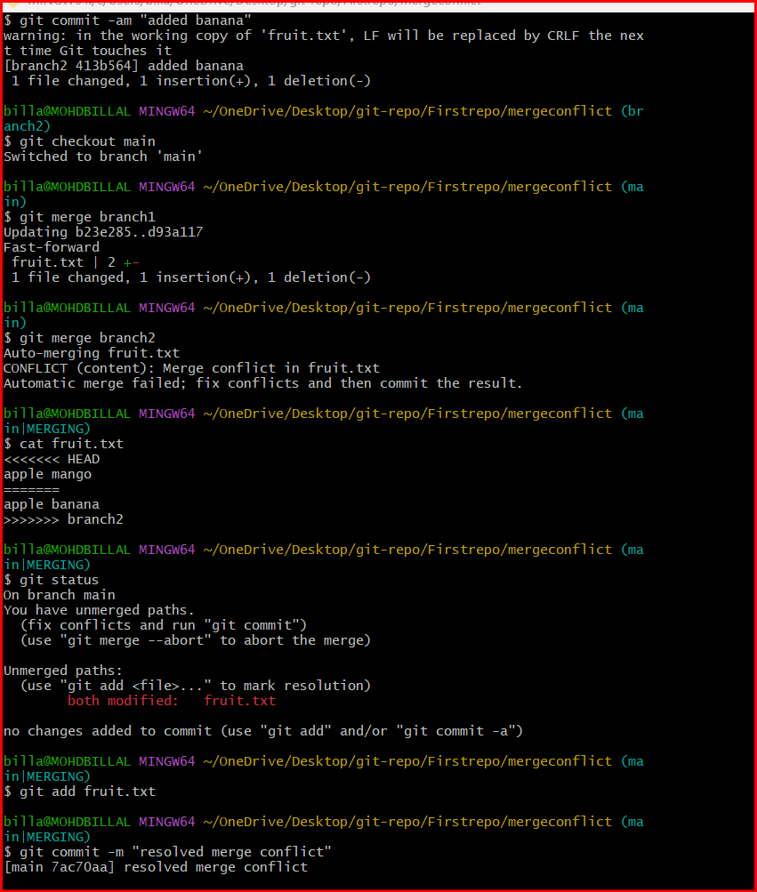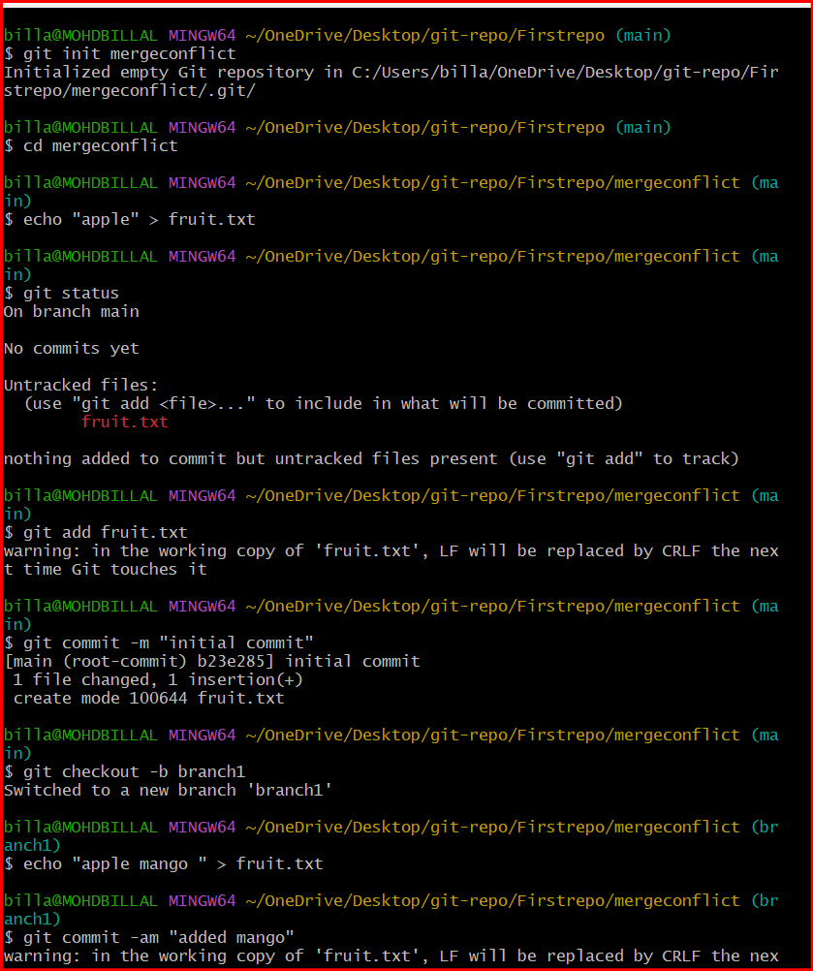
- Recover Deleted Branch
Git, deleting a branch usually does not delete the commits immediately. The commits still exist in the repository as long as something references them in Git’s history, especially through the reflog.
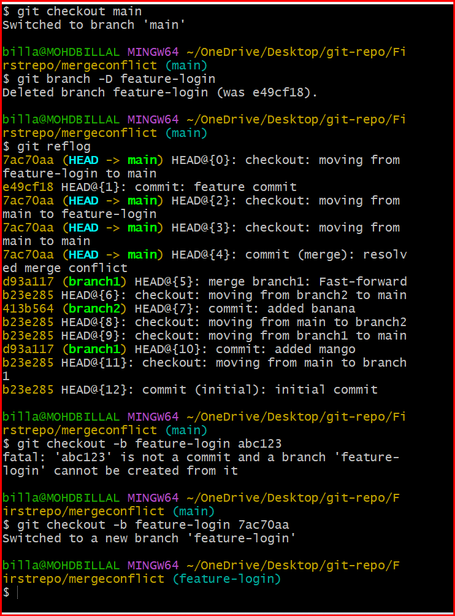
- Delete a local branch and then recover it using the reflog.
A branch in Git is simply a pointer (reference) to a commit.
When you create a branch, Git creates a new pointer that moves forward as new commits are added.


- Undo Wrong Push
A wrong push happens when a developer pushes an incorrect commit or change to a remote repository (like GitHub, GitLab, or Bitbucket).

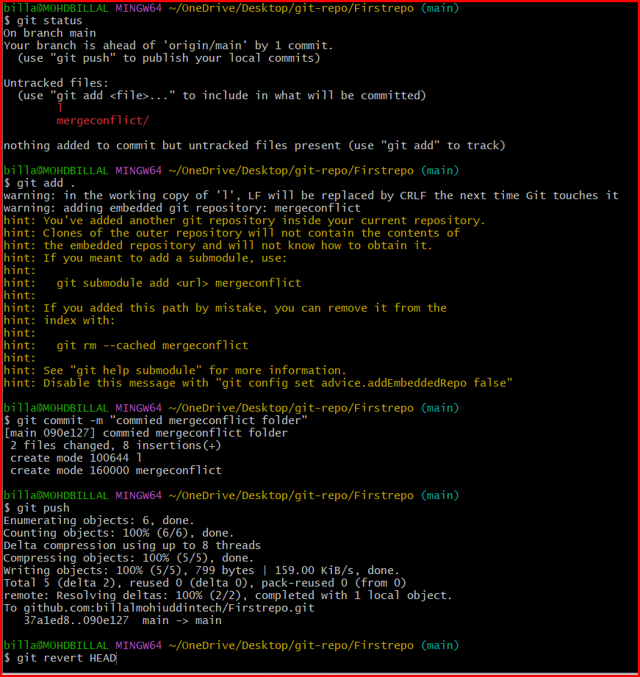

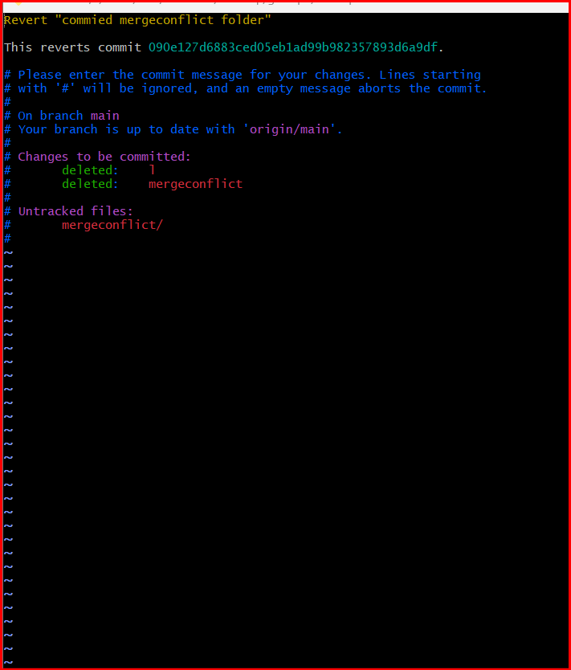
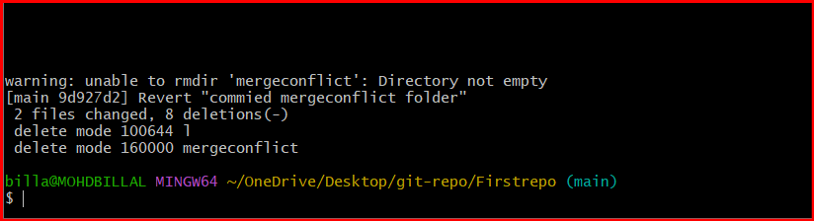
- Push a wrong commit to GitHub, then undo it without losing history.
- Amend a Commit

Amending a commit means modifying the most recent commit in Git.
It allows you to change the commit message or add/remove files that should have been included in the last commit.
Instead of creating a new commit, Git replaces the previous commit with an updated one.

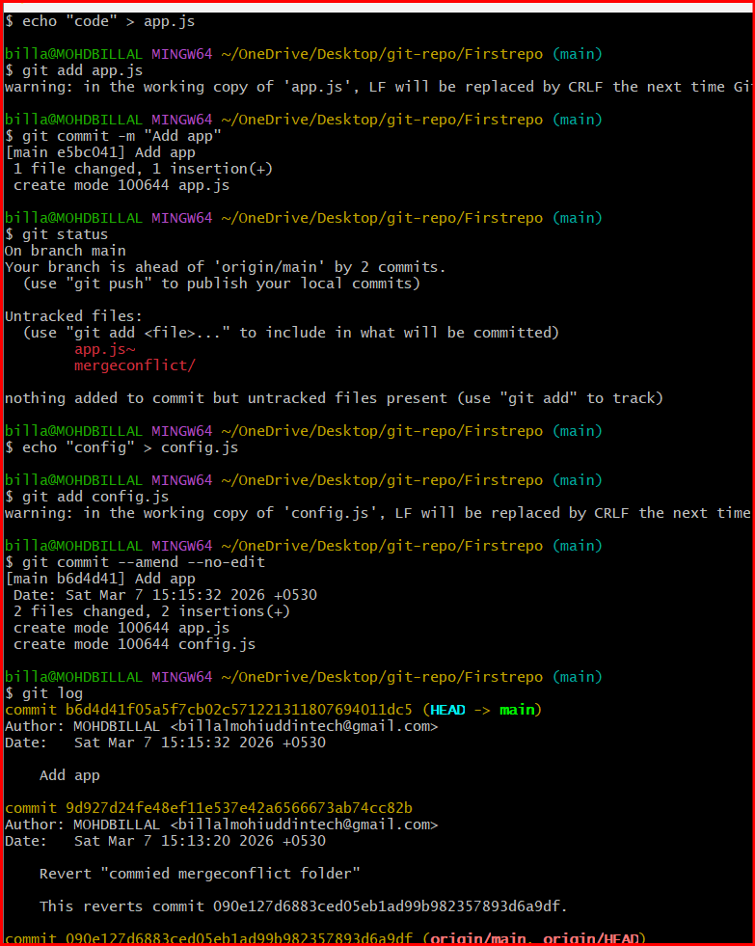

- Cherry-pick a Commit
Take a specific commit from one branch and apply it to another branch.
Cherry-picking in Git means selecting a specific commit from one branch and applying it to another branch.
Instead of merging the entire branch, Git copies only the chosen commit and applies the same changes to the current branch.

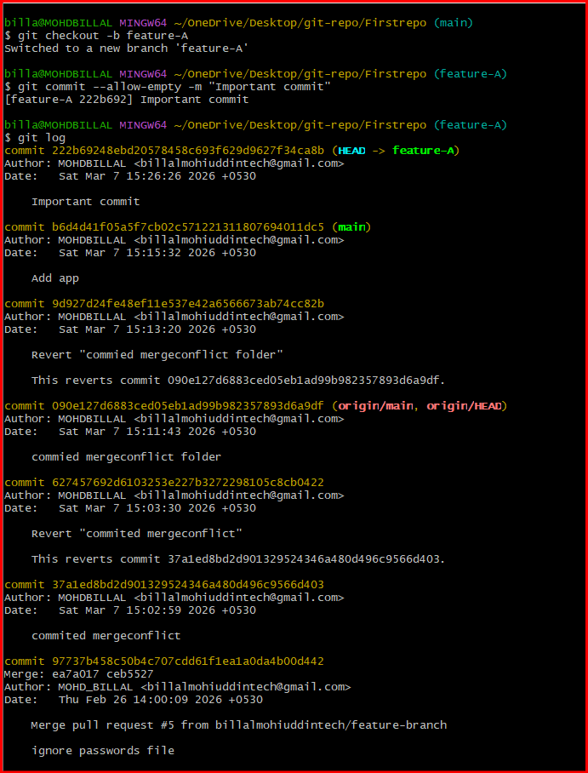

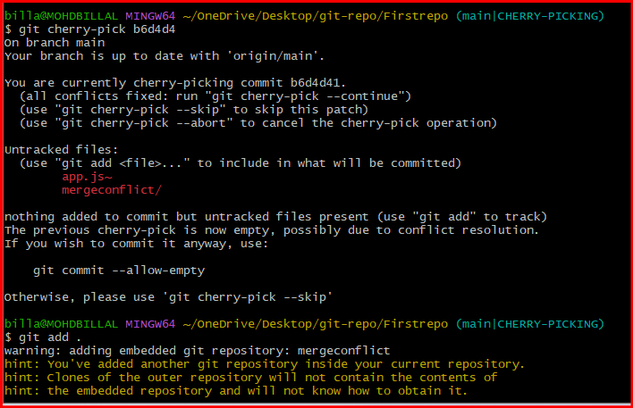

- Interactive Rebase
Reorder and squash multiple commits into a single clean commit.
I nteractive rebase is a Git feature that allows developers to edit, reorder, combine, or remove commits before merging them into another branch.
It helps clean up commit history by organizing multiple small commits into a single meaningful commit.
The command used is:

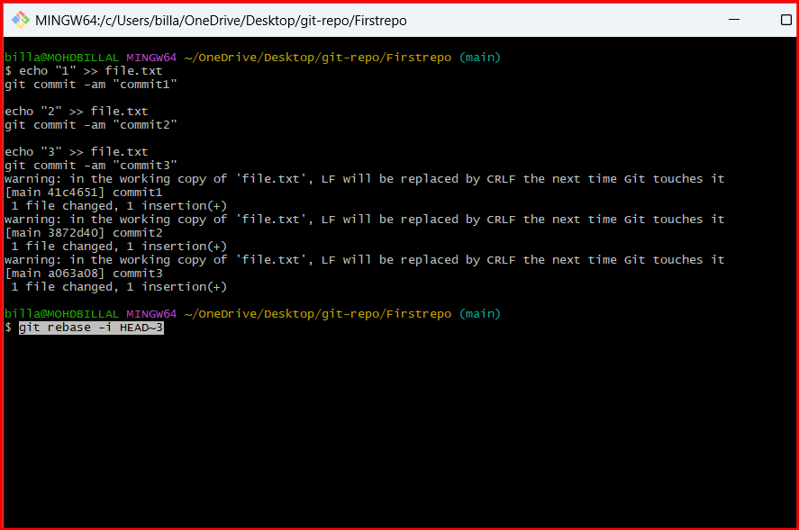
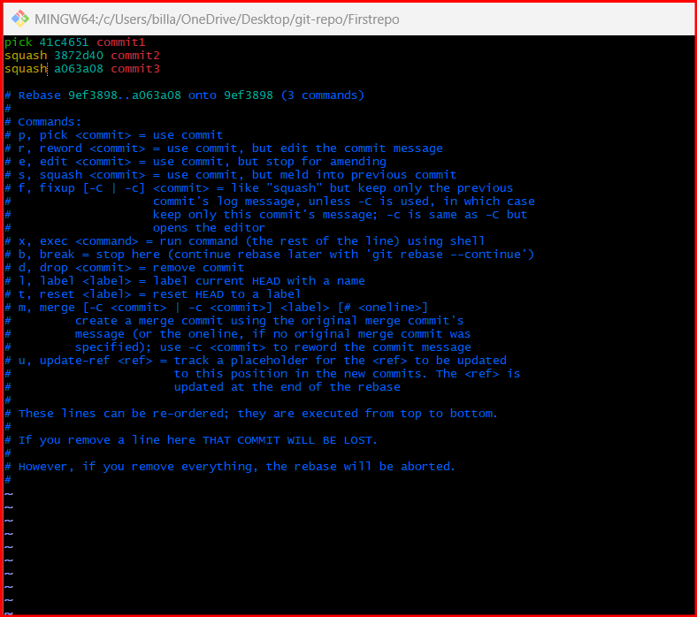
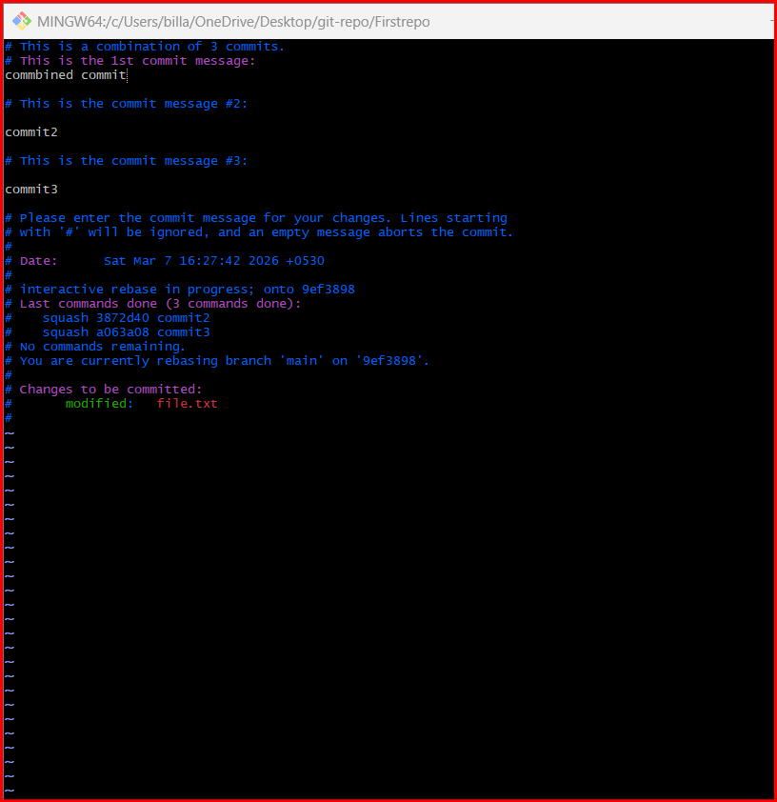
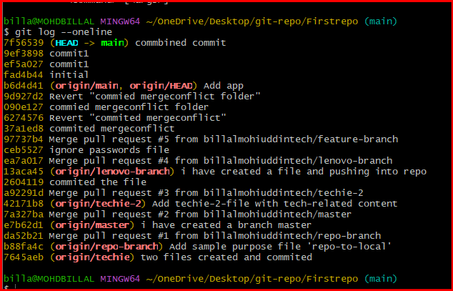

- Tagging & Release
Create a version tag (v1.0), push it to GitHub, then delete and restore it.
A tag in Git is a reference that points to a specific commit in the repository’s history.
Tags are mainly used to mark important points in the project, such as software versions or releases.
For example:
- v1.0
- v2.0
- v1.1-beta

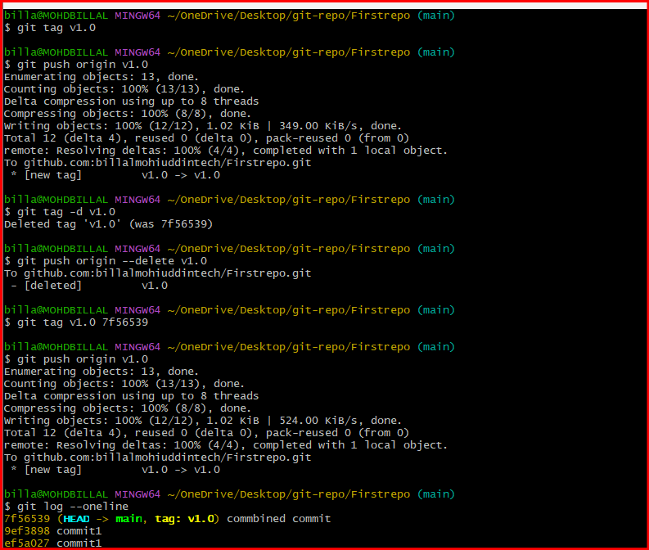

9. Clone with Sparse Checkout
Clone only a subdirectory of a repo using sparse checkout.
Sparse checkout is a Git feature that allows developers to clone or checkout only specific directories or files from a repository instead of downloading the entire project.
This is useful when a repository is very large, but the developer only needs to work on a particular folder or component.

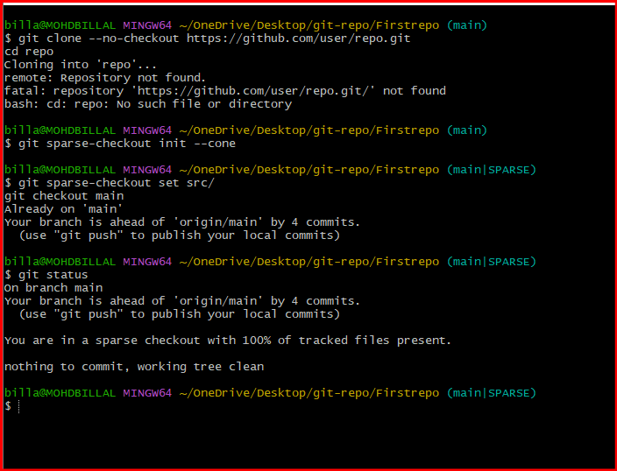

10. Reset vs Revert Challenge
Demonstrate the difference between git reset --hard and git revert in a repo
In Git, reset and revert are commands used to undo changes in a repository.
However, they work in different ways and are used in different situations.
- git reset modifies the commit history.
- git reset is used to move the branch pointer to a previous commit, effectively removing commits from the history.
- git revert creates a new commit that reverses the changes.
- git revert is used to undo the changes of a previous commit by creating a new commit.
- Instead of removing the commit from history, Git adds another commit that reverses it.

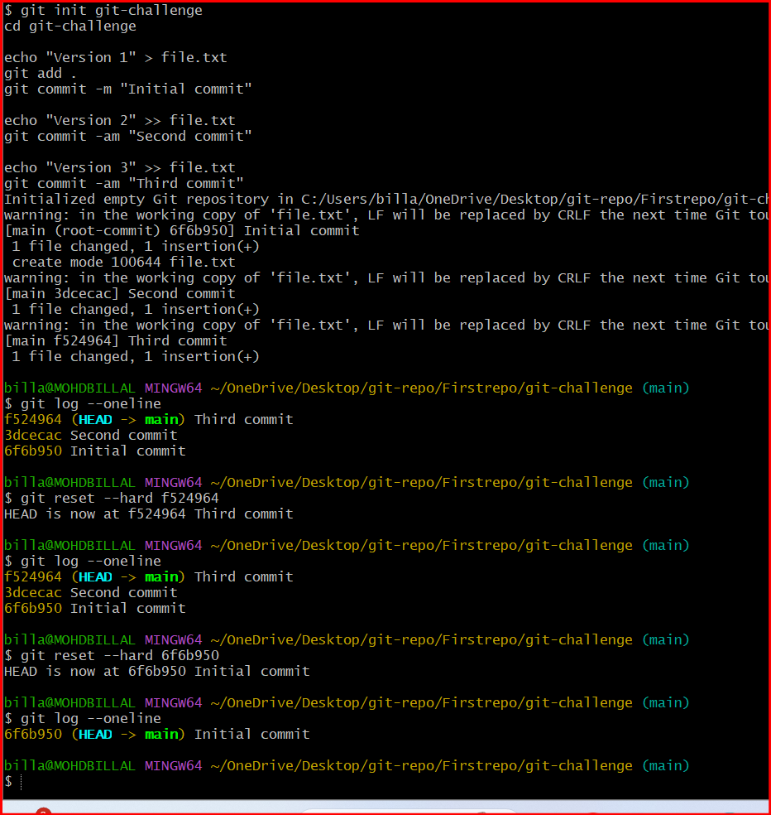

11. Detached HEAD Challenge
In Git, HEAD is a reference that points to the current commit you are working on.
Normally, HEAD points to the latest commit of the current branch.
A Detached HEAD occurs when the HEAD points directly to a specific commit instead of a branch.
This usually happens when you checkout a commit hash, tag, or previous commit.

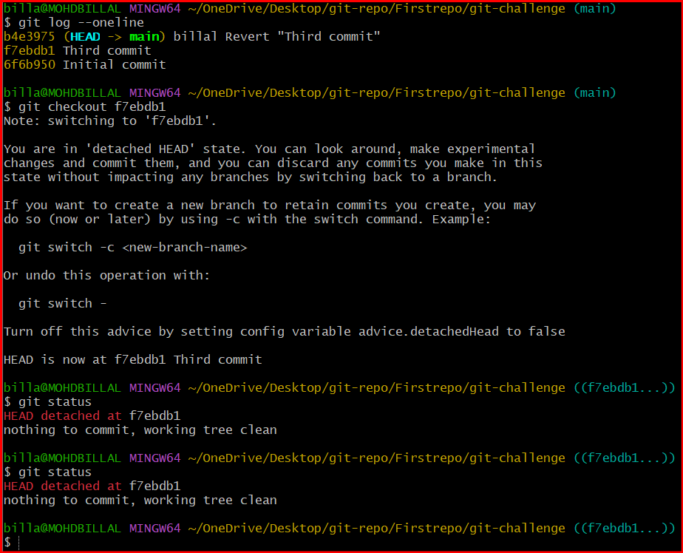

12. Squash Merge vs Rebase Merge
Show the difference between squash merge and rebase merge with evidence.
Both Squash Merge and Rebase Merge are methods used to combine changes from one branch into another branch in Git.
They help integrate feature branches into the main branch but manage commit history differently.
A Squash Merge combines all commits from a feature branch into a single commit before merging it into the target branch.
This means the entire work done in the feature branch appears as one commit in the main branch.

Rebase Merge moves the commits from a feature branch and reapplies them on top of another branch, creating a linear commit history.
Instead of combining commits, it keeps each commit separate

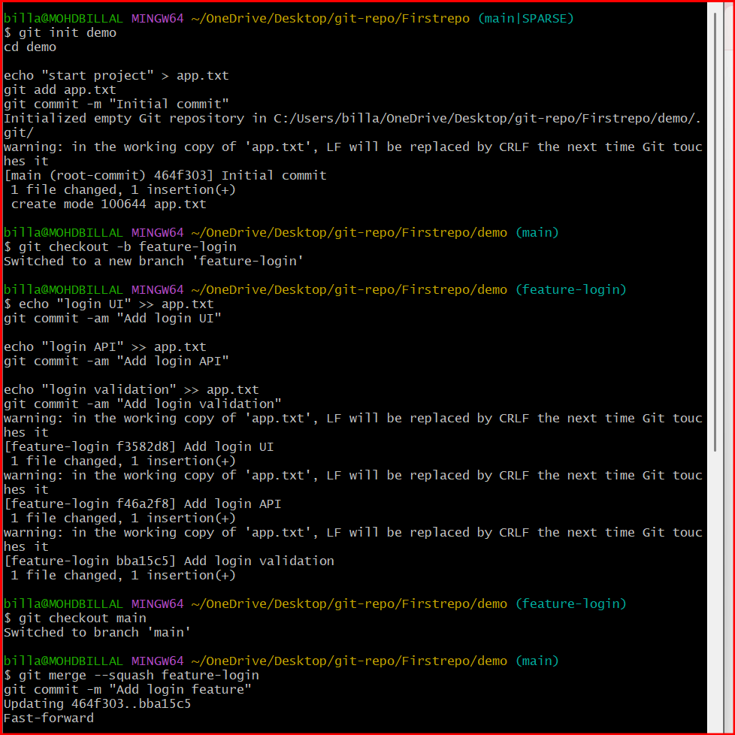

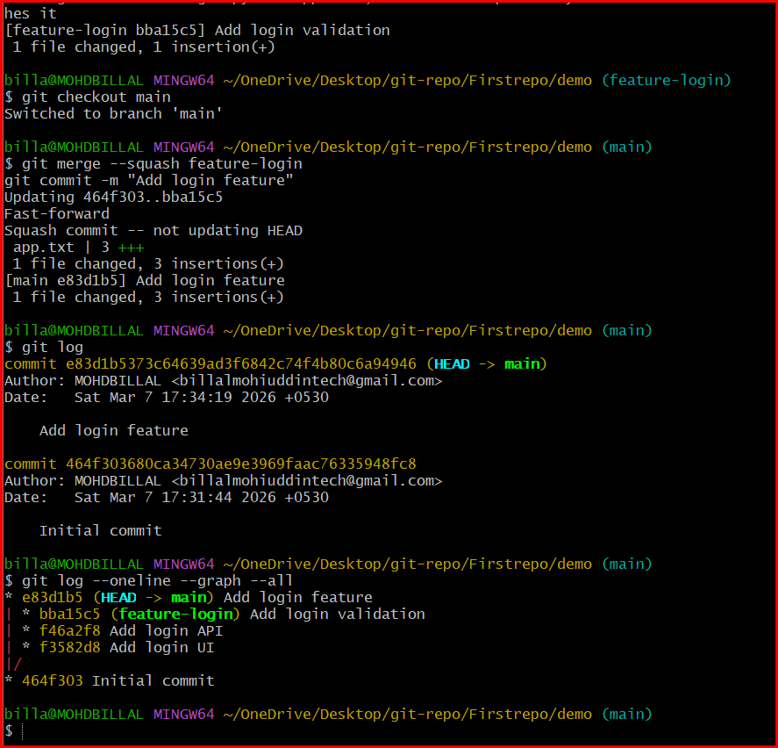

13. Fork & Pull Request Workflow
Fork a repo, make a change, and submit a pull request to the original repo.
Forking is the process of creating a personal copy of another user's repository on your own account (usually on platforms like GitHub).
The forked repository allows developers to experiment and make changes without affecting the original repository.
A Pull Request (PR) is a request sent to the original repository asking the maintainers to review and merge your changes into their project.
The Fork & Pull Request workflow is commonly used in open-source projects where developers do not have direct write access to the main repository.

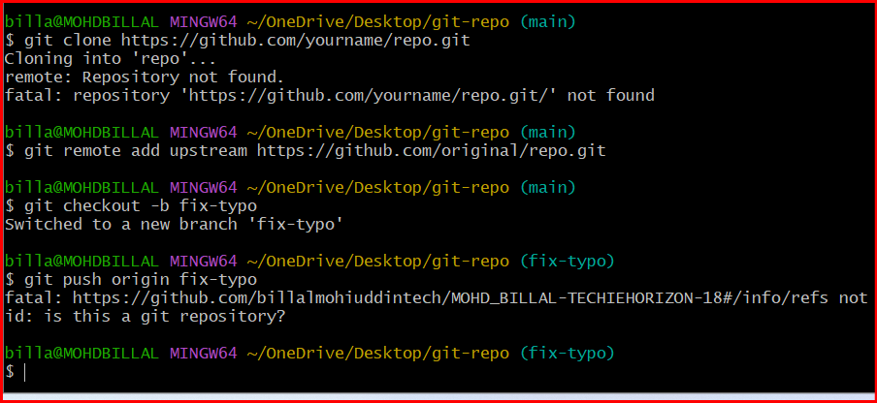

14. Recover Lost Commit
Commit something, reset hard, and then recover it using git reflog.
A lost commit in Git refers to a commit that seems to disappear from the project history due to operations like:
- git reset --hard
- deleting a branch
- rebasing commits
- switching branches without saving changes
Even though the commit is not visible in the normal commit history (git log), Git usually still keeps the commit internally for some time.

